# Build instructions for CAN4DC v6-3.

These are the Building Instructions for the CBUS Analogue DC Quad throttle (CAN4DC).

Do take a few minutes to read right through these Instructions before commencing assembly and checking that you have the parts listed below.

These instructions refer to version 6-3 of the PCB.

Static Precautions are vital when handling the major Integrated Circuits, such as the PIC, and MCP2652 which should be left in their protective bag or tube until instructed to install.

The CAN4DC Circuit Diagram is on page 6.

Throughout these instructions there are a number of Checks. If a check fails then it is important to resolve the problem before continuing with the build.

## Tools Required

* Soldering iron
* Solder
* 3mm flat bladed screwdriver
* Side cutters
* Volt meter
* 5V / 12V Power supply
* Knife

## Parts List

|  |  |  |  |
| --- | --- | --- | --- |
| **Reference** | **Quantity** | **Value** | **Notes** |
|  | 1 | CAN4DC PCB |  |
| C1,C3 | 2 | 47uF electrolytic 6V |  |
| C2,C4,C6,C7,C8,C9,C15,C16 | 8 | 100nF 16V |  |
| C10,C11,C12,C13 | 4 | 10n 16V |  |
| C14 | 1 | 10uF Tantalum 16V |  |
| C17 | 1 | 1uF NOT FITTED | Not fitted |
| D1,D2,D3,D4,D5,D6,D7,D8,D9, D10,D11,D12,D13,D14,D15,D16 | 16 | 1N5818 |  |
| D17 | 1 | 3mm yellow LED |  |
| D18,D19,D20,D21 | 4 | 3mm red LED |  |
| D22 | 1 | 1N4148 |  |
| H1 / H2 | 1 | 6x1 .1 in pitch through-hole header male | Fit only 1 of these headers |
| K1,K2,K3,K4 | 4 | 2 position 0.2 in pitch screw-terminal block |  |
| K5,K6 | 2 | 4 position 0.2 in pitch screw connector |  |
| R1,R3,R4,R5,R6,R7,R18 | 7 | 1K0 0.25W |  |
| R2 | 1 | Wire link |  |
| R8,R9,R10,R15 | 4 | 0R5 Metal Oxide |  |
| R11,R12,R13,R14 | 4 | 10K Metal Film 0.25W |  |
| R19 | 1 | 25K Metal Film 0.25W |  |
| SW1 | 1 | Normally open SPST momentary pushbutton |  |
| U1 | 1 | PIC24HJ128GP502 |  |
| U1 | 1 | 28pin 0.3 DIL socket |  |
| U2,U3 | 2 | L298N |  |
| U4 | 1 | MCP2562 |  |
| U4 | 1 | 8pin 0.3 DIL socket |  |
| U5 | 1 | LM7833 |  |
| XF1 | 1 | 4MHz resonator |  |

## Build and Check steps

1. Fit power connector K6 with the holes for the wires facing outwards.
2. Fit C1, C3 electrolytic capacitors. Ensure the lead next to the 0 on the can goes into the hole opposite the hole marked ‘+’.
3. Fit C2, C4, C6, C7, C8, C9, C15, C16 ceramic capacitors.
4. Fit U5 Voltage regulator. 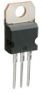Ensure that the metal tab flat back goes towards the edge of the PCB.
5. Fit the U1 28pin DIL IC socket. Ensure the notch of the socket is at the pin 1/28 end.
6. Fit the U4 8pin DIL IC socket. Ensure the notch of the socket is at the pin 1/8 end. Note that U1 and U4 are oriented in opposite directions.

Check that the board looks similar to the picture below.

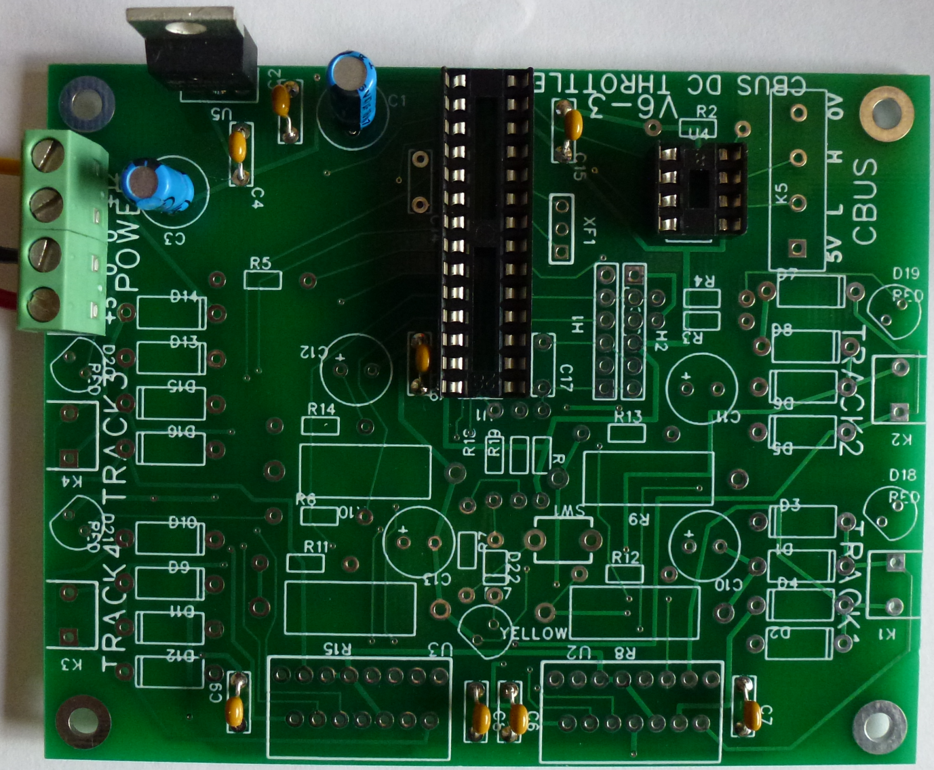

1. Connect +12V, +5V and 0V connections to the Power connector **ensuring the correct terminals are used**. Check that none of the components get warm or hot. If they do get warm then disconnect the power immediately.
2. Connect a Voltmeter negative probe to the 0V (the spare 0V screw terminal on the power connector or the back plate with the fixing hole of the voltage regulator are good places).

Check the voltages at the following points. Tick the measurements off as you go through the table:

|  |  |  |  |
| --- | --- | --- | --- |
| **Point** | **Expected Voltage** | **Voltage Measured** | **OK** |
| U1 pin 8 | 0V |  |  |
| U1 pin 13 | 3.3V |  |  |
| U1 pin 19 | 0V |  |  |
| U1 pin 27 | 0V |  |  |
| U1 pin 28 | 3.3V |  |  |
| H1 pin 2 | 3.3V |  |  |
| H2 pin 4 | 3.3V |  |  |
| U4 pin 2 | 0V |  |  |
| U4 pin 3 | 5V |  |  |
| U2 pin 4 | 12V |  |  |
| U2 pin 8 | 0V |  |  |
| U2 pin 9 | 5V |  |  |
| U3 pin 4 | 12V |  |  |
| U3 pin 8 | 0V |  |  |
| U3 pin 9 | 5V |  |  |

1. **Disconnect the power**.
2. Fit the C14 tantalum capacitor ensuring the correct orientation. The + lead goes closest to pin 20 of U1, away from the bottom edge of the board.
3. Fit the XF1 4MHz resonator. 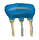 This can go in either way around.
4. Fit the yellow LED D17 ensuring the correct orientation. The - of the LED is marked with a flat on the PCB silkscreen, this is the shorter of the 2 leads.
5. Fit the 1KΩ (brown-black-red) resistors R1, R7 and R18. These can go in either way around.
6. Fit the 25KΩ (red-green-orange) resistor R19. This can go in either way around.
7. Fit the diode D22 ensuring the correct orientation. The band on the diode case should match the band on the silkscreen.
8. Fit the push button switch. 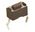This can go in either way around.
9. Fit a wire link in place of resistor R2.
10. Fit the 100nF capacitors 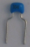C2, C4, C16 and C17. These can go in either way around.
11. Fit the Cbus Connector K5 connector with the holes for the wires facing outwards.
12. Fit the ICSP header strip into either the H1 or H2 position. Cut a length of 6 pins from the header strip. If you are using the PicKit 3 programmer fit the 6 pin header into H1. If you are using a MERG cable then remove pin 3 and fit the header into H2.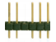
13. Reconnect the power ensuring **the polarity is correct**.

Check that the yellow LED should light *dimly* to verify the polarity of the LED.

1. **Disconnect** **the** **power**.
2. **Whilst taking anti-static precautions** insert the PIC24HJ128GP502 into the socket. It may be necessary to press each side of the IC against a flat surface to bend the pins in slightly so that the IC can be pushed into the socket. Verity that the PIC is inserted so that pin 1 is near the notch on the socket and the indication on the PCB.

Check that the board looks similar to the picture below.

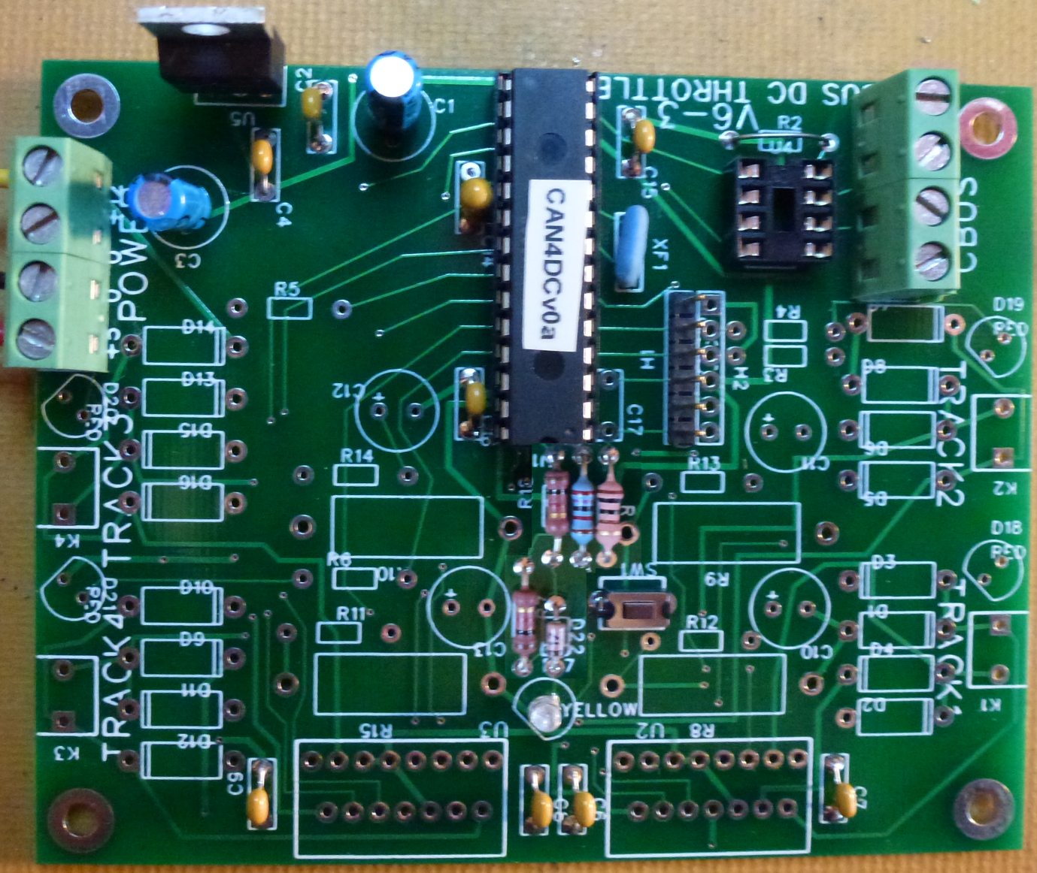

1. Reconnect the power ensuring **the polarity is correct**.

Check that the yellow LED should light *brightly* to indicate that the PIC is running.

Check that pushing and holding the push button for 3 seconds causes the yellow LED to flash at about once a second.

1. **Disconnect the power**.
2. **Whilst taking anti-static precautions** remove the PIC and carefully put back into its anti-static bag.

The board may be partially populated if less than 4 throttles are required:

|  |  |
| --- | --- |
| Number of throttles required | Components to be fitted |
| 1 | K1, C6, D18, R3, R8, R12, D1, D2, D3, D4, U2 |
| 2 | As throttle 1 plus: K2 C7, D19, R4, R9, R13, D5, D6, D7, D8 |
| 3 | As throttle 2 plus: K4 C9, D20, R5, R11, R15, D13, D14, D15, D16, U3 |
| 4 | As throttle 3 plus: K3 C8, D21, R6, R10, R14, D9, D10, D11, D12 |

1. Fit the components necessary for the number of throttles to be supported. Ensure the correct polarity of the diodes, motor controllers (U2 and U3) and connectors. The - of the LED is marked with a flat on the PCB silkscreen, this is the shorter of the 2 leads.

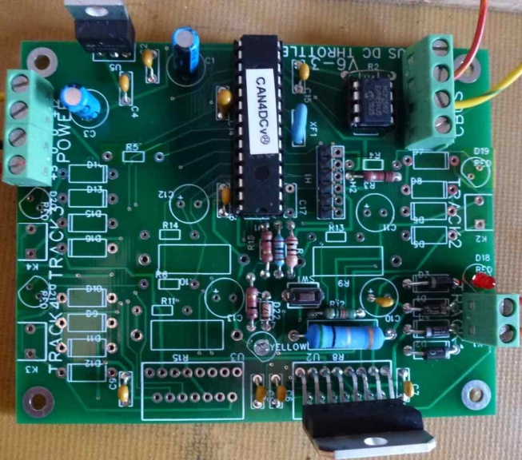 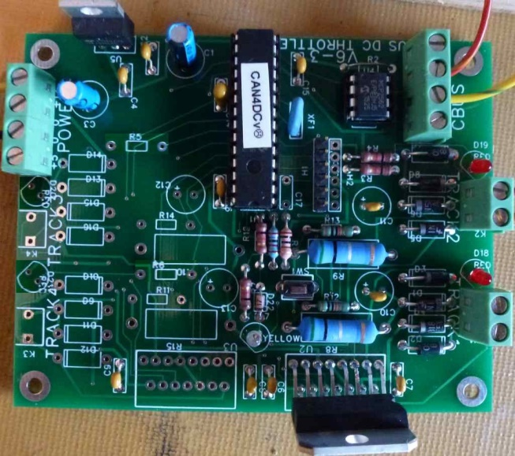

1 throttle 2 throttles

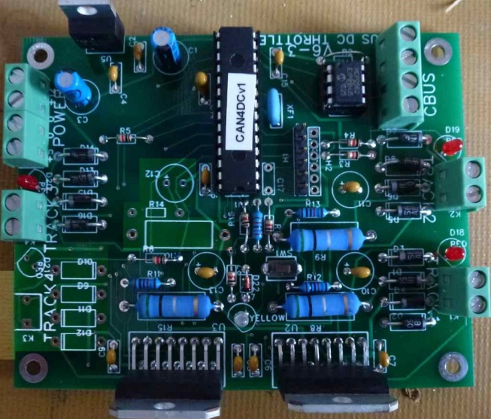 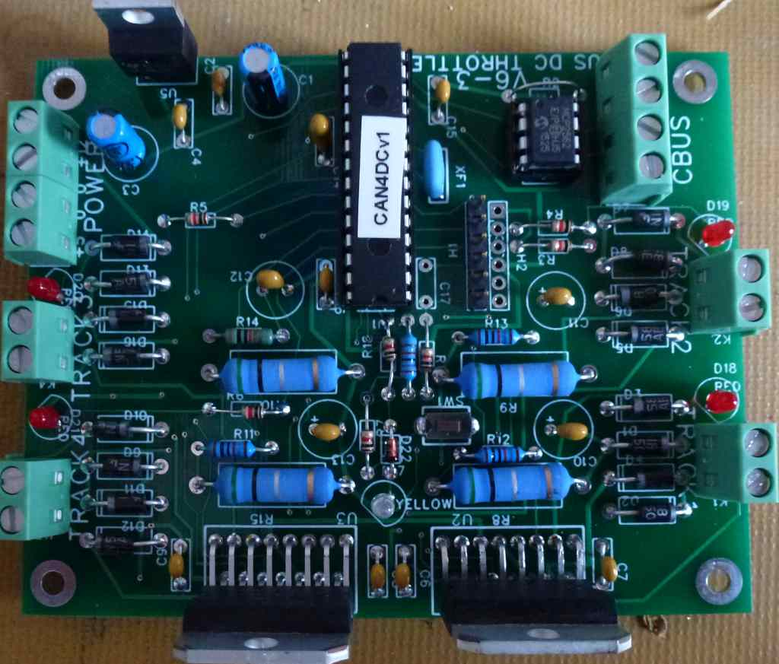

3 throttles 4 throttles

1. Reconnect the power **ensuring the polarity is correct**.

Check that the completed board looks similar to the pictures above, but without the ICs inserted and possibly with different coloured resistors.

Check the PCB trackside for any unsoldered or bridged joints.

Check the voltages at the following points. Tick the measurements off as you go through the table:

|  |  |  |  |
| --- | --- | --- | --- |
| **Point** | **Expected Voltage** | **Voltage Measured** | **OK** |
| U1 pin 8 | 0V |  |  |
| U1 pin 13 | 3.3V |  |  |
| U1 pin 19 | 0V |  |  |
| U1 pin 27 | 0V |  |  |
| U1 pin 28 | 3.3V |  |  |
| H1 pin 2 | 3.3V |  |  |
| H2 pin 4 | 3.3V |  |  |
| U4 pin 2 | 0V |  |  |
| U4 pin 3 | 5V |  |  |
| U2 pin 4 | 12V |  |  |
| U2 pin 8 | 0V |  |  |
| U2 pin 9 | 5V |  |  |
| U3 pin 4 | 12V |  |  |
| U3 pin 8 | 0V |  |  |
| U3 pin 9 | 5V |  |  |

1. **Disconnect the power**.
2. **Whilst taking anti-static precautions** reinsert the PIC24HJ128GP502 into the socket. Verity that the PIC is inserted so that pin 1 is near the notch on the socket and the indication on the PCB.
3. **Whilst taking anti-static precautions** insert MCP2652 into the socket. It may be necessary to press each side of the IC against a flat surface to bend the pins in slightly so that the IC can be pushed into the socket. Verity that the PIC is inserted so that pin 1 is near the notch on the socket and the indication on the PCB.

Check that thetwo ICs are inserted at opposite orientations to each other.

1. Reconnect the power ensuring **the polarity is correct**.

Check that the yellow LED should light to indicate that the PIC is running.

Check that pushing and holding the push button for 3 seconds causes the yellow LED to flash at about once a second.

Check that pushing and holding the push button for 3 seconds causes the yellow LED to stop flashing and light continuously.

Build Complete

## Appendix: PCB silk screen

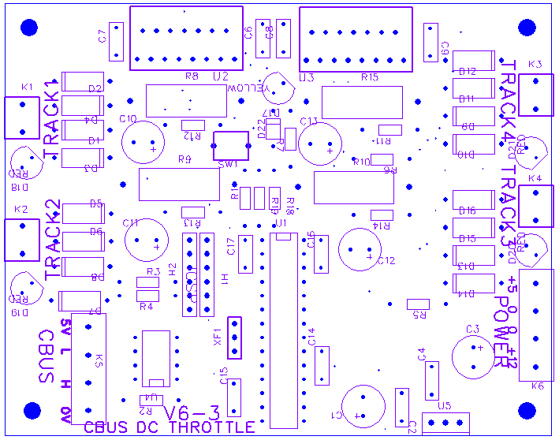

## Appendix: Schematic

